LSP 121 Placement Exam Practice Problems
with Solutions

Databases
Create a database for the DePaul basketball ticket system. A customer can purchase one or more tickets. You should record the customer’s name, address, etc, and then a list of each ticket that has been sold to this customer (record row number, seat number, date of game, time of game). Finally, create a form that will allow someone to enter and view the records, and a report that lists each customer along with each seat assignment.

For example, we might have the following customers:

Smith, 123 Main Street, Chicago, IL, Row 4, Seat 6, 3/20/12, 7:00, Row 4, Seat 7, 3/20/12, 7:00
Jones, 33 Elm, Des Plaines, IL, Row 50, Seat 1, 1/12/12, 7:00, Row 50, Seat 2, 1/12/12, 7:00, Row 50, Seat 3, 1/12/12, 7:00, Row 50, Seat 4, 1/12/12, 7:00

The two Microsoft Access tables (in first order normal form) might look like this:

Customer Info
LastName | Address | City | State | Customer ID
Smith | 123 Main Street | Chicago | IL | 1234
Jones | 33 Elm | Des Plaines | IL | 8898

Customer Seats
Row | Seat | GameDate | GameTime | Customer ID
4 | 6 | 3/20/2012 | 7:00:00 PM | 1234
4 | 7 | 3/20/2012 | 7:00:00 PM | 1234
50 | 1 | 1/12/2012 | 7:00:00 PM | 8898
50 | 2 | 1/12/2012 | 7:00:00 PM | 8898
50 | 3 | 1/12/2012 | 7:00:00 PM | 8898
50 | 4 | 1/12/2012 | 7:00:00 PM | 8898

Perform a query which displays all of Smith’s tickets:

Query1
LastName | Row | Seat | GameDate | GameTime
Smith | 4 | 6 | 3/20/2012 | 7:00:00 PM
Smith | 4 | 7 | 3/20/2012 | 7:00:00 PM

Perform a query which displays the number of seats (count) for customer Jones:

Query2
LastName | CountOfSeat
Jones | 4

Descriptive Statistics
Using SPSS (preferably) and the file IncomeGaps.xls (which can be found on the qrc.depaul.edu website under the tab Excel Files), find the mean, median, range, min, max, standard deviation, first quartile, and third quartile for the Bottom Fifth column of income data. If you examine just the Bottom Fifth data, is there an outlier? Create the histogram that represents this data.

Statistics
BottomFifth
N | Valid | 50
 | Missing | 0
Mean |  | 10409.36
Median |  | 10265.50
Std. Deviation |  | 2524.387
Range |  | 9452
Minimum |  | 6257
Maximum |  | 15709
Percentiles | 25 | 8520.50
 | 50 | 10265.50
 | 75 | 12454.50

There is one outlier: Utah. Its value is greater than mean + (2 x standard deviation).

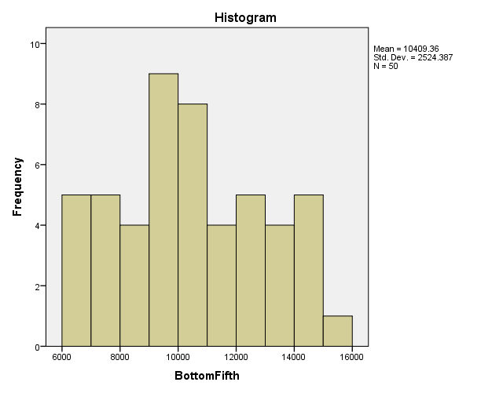

Correlation
Using either Excel or SPSS and given the data set WineConsumption.xls (on the qrc.depaul.edu website under the tab Excel Files under the link OlderData at the bottom of the page), determine if there is a correlation between the average annual amount of wine consumed and the heart disease death rate.

There is a strong negative correlation (-0.843). As wine consumption goes up, death from heart disease goes down.

Correlations
 |  | AverConsump | HeartDisRate
AverConsump | Pearson Correlation | 1 | -.843**
 | Sig. (2-tailed) |  | .000
 | N | 19 | 19
HeartDisRate | Pearson Correlation | -.843** | 1
 | Sig. (2-tailed) | .000
 | N | 19 | 19
**. Correlation is significant at the 0.01 level (2-tailed).

Number systems and conversions
The world’s fastest moving tectonic plate is the Pacific Plate. It moves at the lightning speed of four inches a year. What is that in miles per hour?

4 inches / 1 year x 1 foot/12 inches x 1 mile/5280 feet x 1 year/365 days x 1 day/24 hours = 7.21 x 10⁻⁹ miles / hour

What is the decimal value of binary 101101?

45

What is the binary value of decimal 57?

111001

Logarithms
Using an Excel spreadsheet, calculate the data rate in bits per second using Nyquist’s equation (data rate = 2 x frequency x log₂(signal levels). Hold the number of signal levels constant at 8 and vary the frequency from 1000 to 10,000 Hz in increments of 500.

Hertz | Data Rate
1000 | 6000
1500 | 9000
2000 | 12000
2500 | 15000
3000 | 18000
3500 | 21000
4000 | 24000
4500 | 27000
5000 | 30000
5500 | 33000
6000 | 36000
6500 | 39000
7000 | 42000
7500 | 45000
8000 | 48000
8500 | 51000
9000 | 54000
9500 | 57000
10000 | 60000

Basic Probability
What is the probability of a 200-year flood this year?

1/200

What is the probability of not rolling a double-6 with two dice?

36 total combinations (6 x 6); only 1 combination of 6 and 6; so 35/36

Suppose event A has a 0.98 probability of occurring and event B has a 0.94 probability of occurring. Compute the odds for event A and the odds for event B.

Event A: 0.98/0.02 = 49 to 1
Event B: 0.94/0.06 = 15.667 to 1

What is the probability of the next five births at a hospital all being girls?

½ x ½ x ½ x ½ x ½ = 0.03125

Studies have shown that Peoria, Illinois is hit by a tornado about every 30 years. What is the probability that Peoria will be hit by a tornado this year? What is the probability that Peoria will be hit by tornados in three consecutive years? What is the probability that Peoria will be hit by at least one tornado in the next 30 years?

1/30 = 0.033
1/30 x 1/30 x 1/30 = 0.000037
1 – 29/30³⁰ = 0.6383

Suppose that license plates are made with three letters followed by three numerals (0-9). How many different license plates are possible?

26 x 26 x 26 x 10 x 10 x 10 = 17,576,000

An insurance policy sells for $500. Based on past data, an average of 1 in 50 policyholders will file a $5000 claim, an average of 1 in 100 policyholders will file a $10,000 claim, and an average of 1 in 200 policyholders will file a $30,000 claim. What is the expected value of a single policy to the insurance company?

500 - (1/50 x 5000) - (1/100 x 10000) - (1/200 x 30000) = $150.00

Algorithms
What are the four basic types of instructions used in computer algorithms/programs?

Sequential
Conditional (if)
Iterative (loop)
Call a pre-existing operation (function)

Using any computer language (or even in English) write an IF statement that performs operation A if MaxValue is less than or equal to 500, else performs operation B.

if MaxValue <= 500 then
perform A
else
perform B
end If

Using any computer language (or even in English) write a loop that performs operations C and D 60 times.

for Row = 1 to 60
perform C
perform D
next Row

